EEZ project – Preparing the HTML help

The SCPI subsystems can be imported into IEXT project using the properly formatted HTML file as described in Adding SCPI commands and queries from HTML help file. This section describes what is necessary to add into HTML help file that the ESP during import can properly detect SCPI subsystem and its commands and queries.
The HTML help file could be created in various HTML editor or general purpose text processing software that has “export to/save as HTML” feature. One of them is also LibreOffice or OpenOffice Writer what will be used in our example. Unfortunately, conversion from .odt to HTML file still does not produce accurate result. Therefore the EEZ WebPublish extension for OpenOffice extension will be used that produce more predictable HTML output.

SCPI subsystem name
All names of SCPI subsystem, commands and queries require unique bookmark at their beginning. SCPI subsystem name is usually at the beginning of the file, and in our example it is “Common command reference” (Fig. 1.).

The SCPI subsystem bookmark name has to begin with _scpi_subsys_ prefix, and it is named _scpi_subsys_ieee488 in our example. To insert bookmark, use Insert … Bookmark … option that will open a new entry form as shown on Fig. 2.
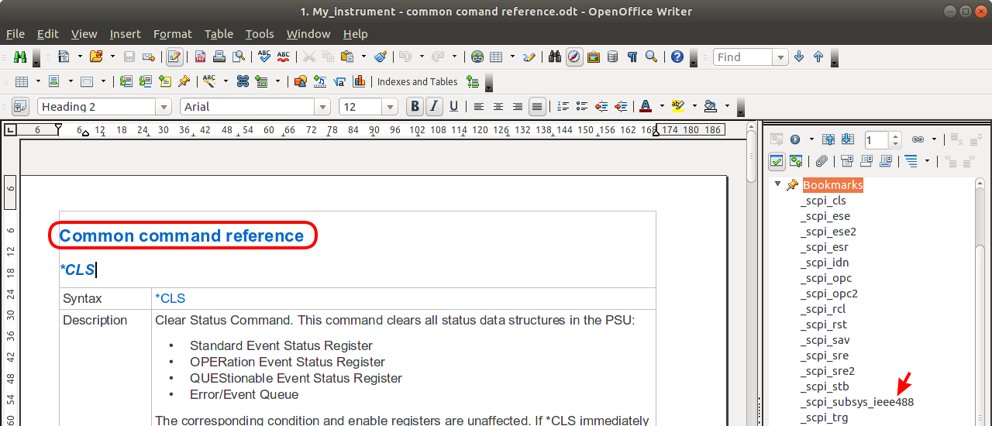Fig. 1: SCPI subsystem title

SCPI command and query name
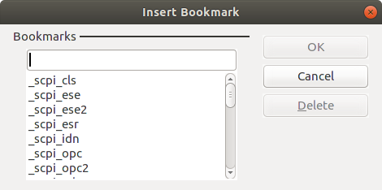Fig. 2: OpenOffice Writer insert bookmark
Each SCPI command and query requires unique bookmark that begins with prefix _scpi_. and as in case of SCPI subsystem name, the text that follows will be used as command name or query. When both command and query form exists for the name of the later we can simply add 2 to make it unique. For example for *OPC and *OPC? We can use _scpi_opc and _scpi_opc2 for bookmarks name as shown in Fig. 3.

SCPI command parameter name and type
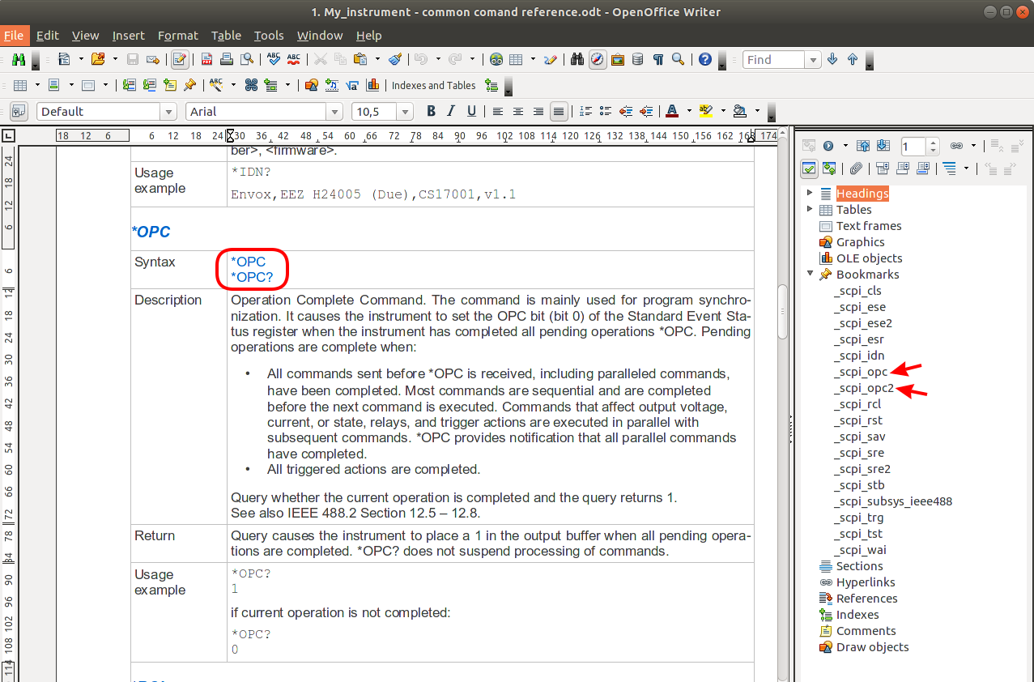Fig. 3: SCPI command and query section
The ESP while importing HTML help file can also detect SCPI command parameter names and types. Recommended form to specify SCPI command parameters is a table as shown in Fig. 4. the following rules are applied here:
- Parameter has to be enclosed with <>
- Enclose parameter in {} brackets if it is mandatory or [] brackets if optional
- More parameters have to be separated by comma (,)
- Each parameter specified in command line has to be specified in separate table row with the same name and also enclosed with <>

Use on of the following labels for the parameter's type (note that numeric values can be defined with any of two possible labels):
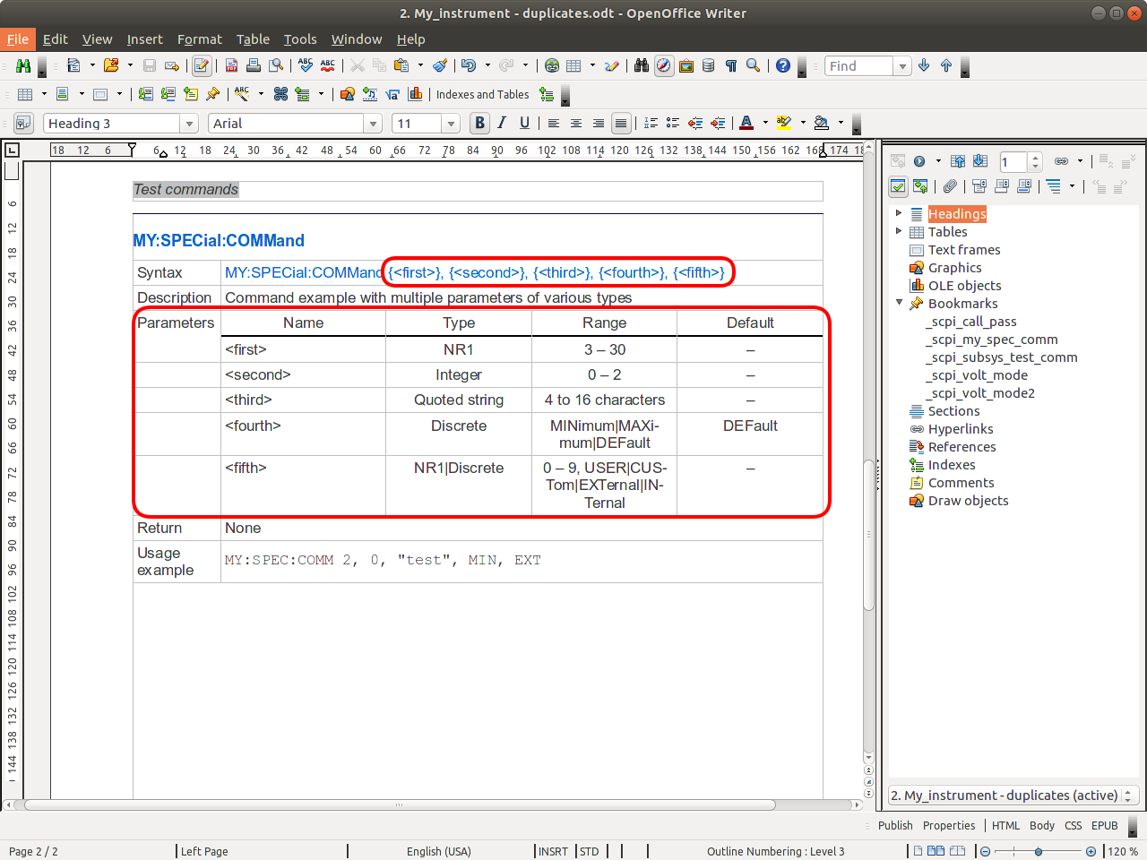Fig. 4: SCPI command parameters table
- Integer or NR1
- Decimal or NR2
- Float or NR3
- Boolean
- Quoted string
- Data block
- Channel list
- Discrete
It is also allowed to use more then one parameter type, e.g. NR1 and Discrete as in case of <fifth> parameter from example shown in Fig. 4. Use “|” character as a separation mark.
Discrete parameter's type can be also detected and its values has to be also separated with a “|” character.
The ESP will report detection of the HTML help file that contain newly defined MY:SPECial:COMMand from our example as shown in Fig. 5. Check Command option to commit its import. The newly detected command will also introduce two enumerations (used for parameter <fourth> and <fifth>) that will be also detected and reported into the separate tab (Fig. 6.).

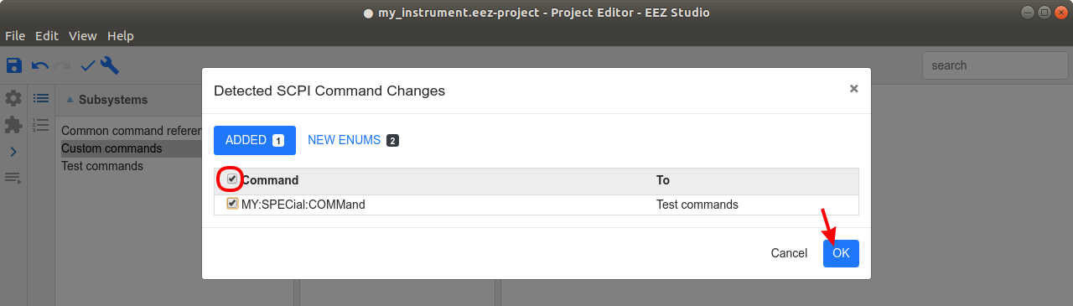Fig. 5: Detected new SCPI command
When detected new items are marked and imported the new command and its parameters will appear in the project as shown in Fig. 7. New enumerations can be found in Enumerations section (Fig. 8).
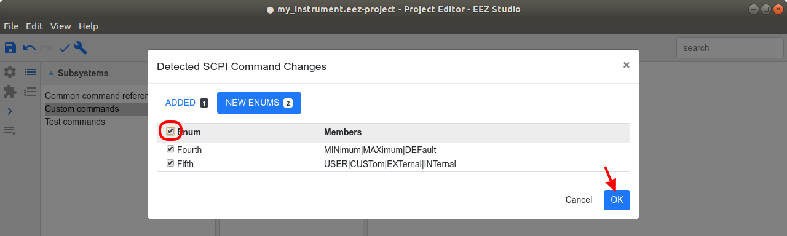Fig. 6: Detected new enumerations

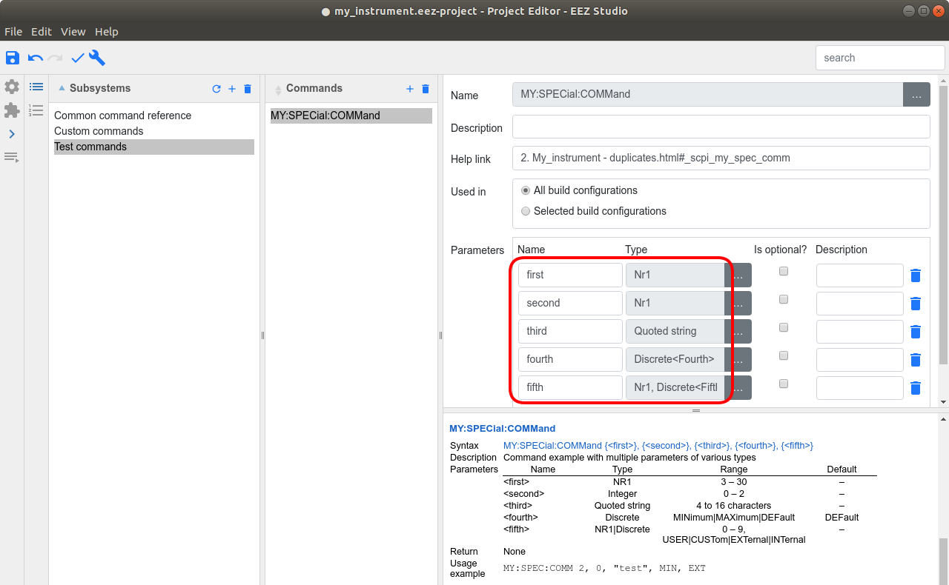Fig. 7: Imported new SCPI commands with parameter definitions

Generating a HTML file
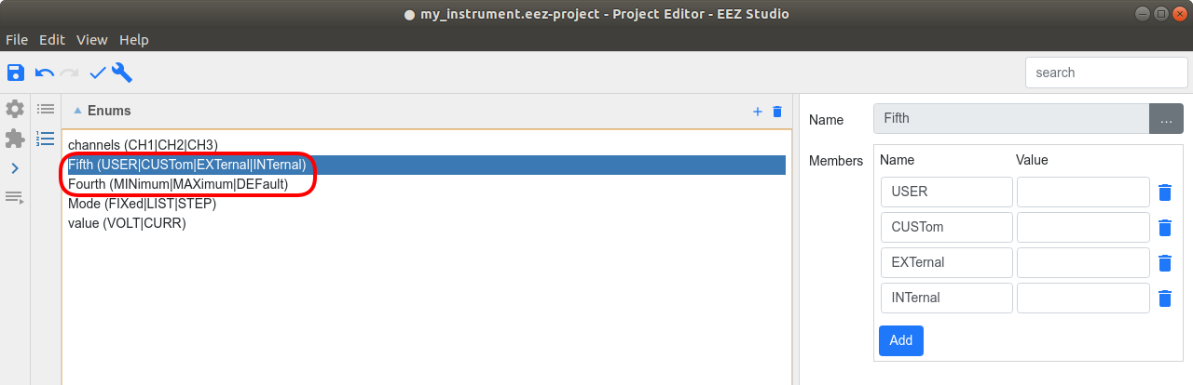Fig. 8: Imported new enumerations
The final step is to convert SCPI subsystem help file formatted as described above to HTML format. In our example the OpenOffice Writer with previously installed EEZ WebPublish extension will be used. Please note that extension installation require OpenOffice Writer restart. The WebPublish extension works with profiles and a HTML profile is required for conversion into HTML format. To check profile, access OpenOffice Extension Manager option (select Tools … Extension manager menu option) and select WebPublish Options (Fig. 9.).

When e.g. default HTML profile is selected for editing (Fig. 10.) check if its parameters are as shown in Fig 11.
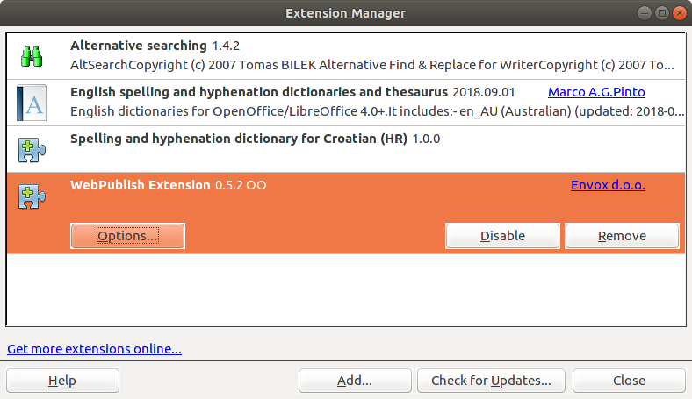Fig. 9: OpenOffice Extension manager

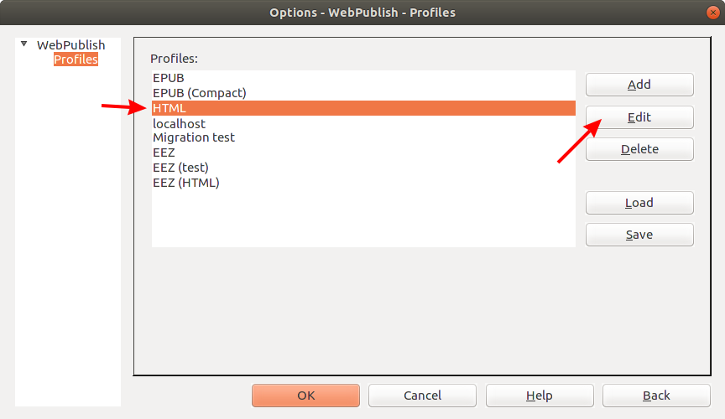Fig. : WebPublish extension profiles
Now we can select from WebPublish toolbar HTML option, select above mentioned HTML profile (Fig. 12) and choose name for the HTML file.
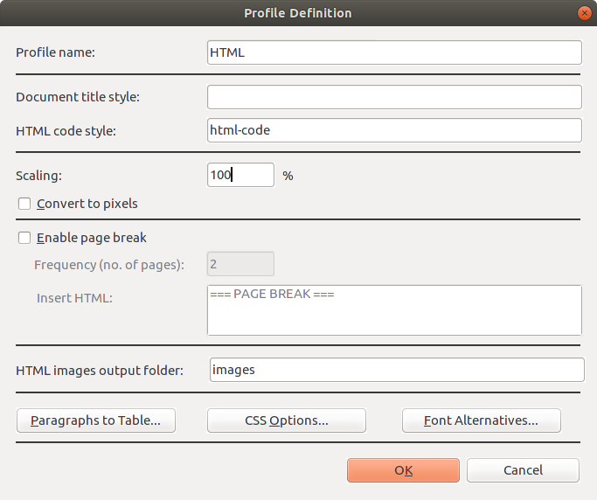Fig. : WebPublish HTML profile definition

The complete above described procedure of creating SCPI subsystem help file that has to be converted into HTML format for importing into EEZ project, can be accomplish with e.g. MS Word. As a final step a Save as option to HTML format has to be selected as shown on Fig. 13.
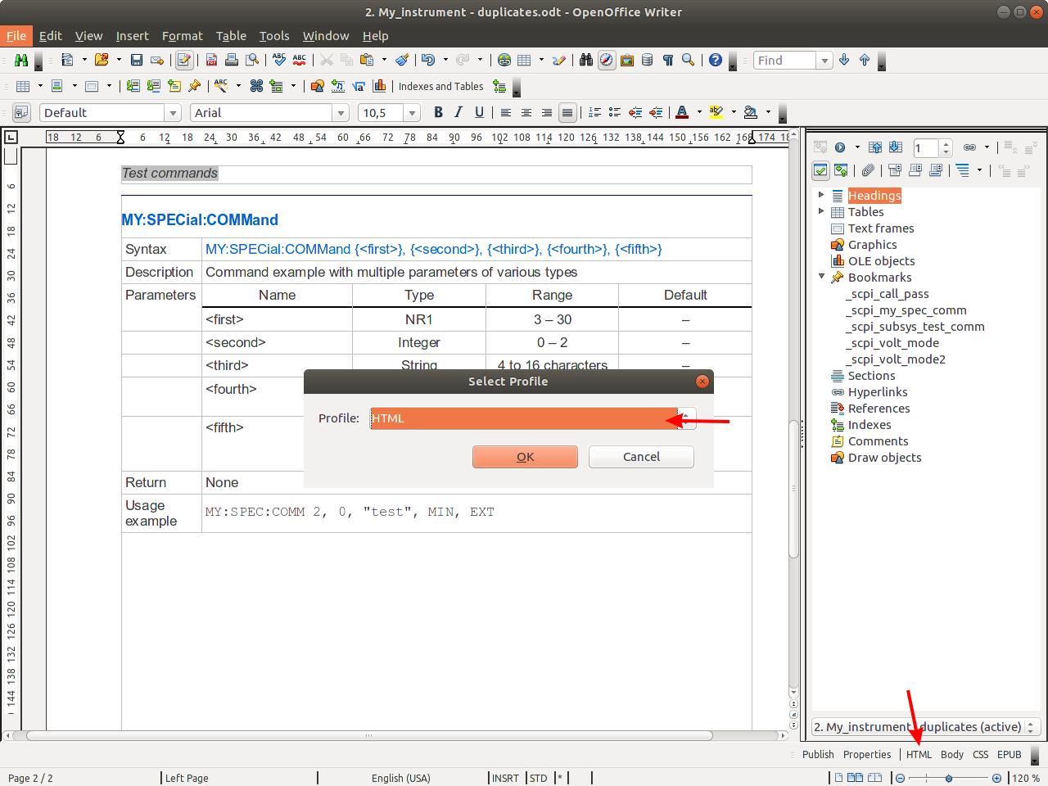Fig. : Select WebPublish conversion to HTML option

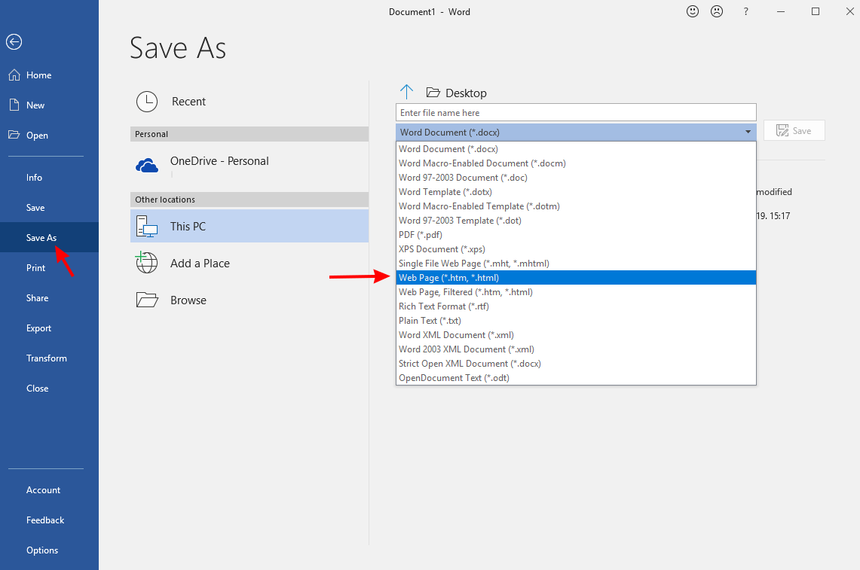Fig. : MS Word Save as HTML option

